Assignment / Activity: Aggregation in Action
Title: Analyze Student Marks Using Aggregation Functions
Instructions : Use https://sqliteonline.com or a local SQL IDE to complete the following:

Q1. Create a table called students with the following columns:
- id (INTEGER, Primary Key)
- name (TEXT)
- marks (INTEGER)

- age (INTEGER)
create table Students
( id int primary key identity(1000,1),
name varchar(20),
grade int check(grade>0 and grade<101));

alter table Students add age int;
update Students set age= 8 where age is null

Q2. Insert at least 5 student records. Example:
INSERT INTO students (id, name, marks, age)
VALUES (1, 'Anjali', 87, 19);
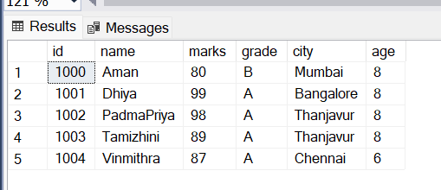

Q3. Write a query to find the total number of students in the table.
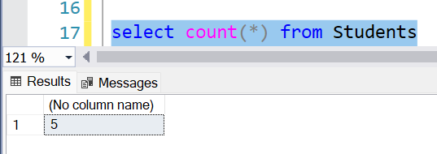

Q4. Write a query to calculate the average marks.
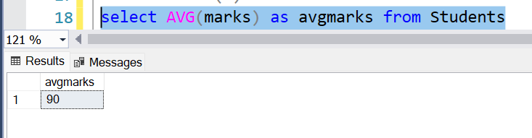

Q5. Write a query to display the minimum and maximum marks together.
